# ELECRONIC KNOW YOUR CUSTOMER(E-KYC) USING RPA

* The project “**Electronic- Know Your Customer** (E-KYC)” is about how to automate the manual process of filling the KYC form. Computer software or a “robot” to capture and interpret existing applications for collecting details of candidates from the Excel sheet, reading the Excel data, generating the template, exporting to pdf. Website is being created for filling the form and then sending a mail to particular candidates.

## The manual process of KYC needs a human to assess and approve the requests, which is liable to mistakes and lot of time consumption and man power. Our proposed system reduces them by automating the whole complete process using a software robot which will be much faster than the manual process, also reduces the time and man power consumption.

## PROBLEM DEFINITION

Electronic-Know Your Customer(E-KYC) processing is basically a time consuming and excruciating process because each employees personal details have to be checked manually, cross checked, send for approval and so on. The entire process take time and is prone to errors due to multiple levels of human scrutiny. Generating the KYC for every candidates can be handed over to a RPA solution which can do this activity automatically and without even any manual intervention during the process. The system is planned to be built using UI path studio and triggered using UiPath Robot*.*

TOOLS USEDUiPath IDE:

UiPath is a software structure to improve automation applications. It runs on Microsoft Windows and it was settled on the top of Net framework and Windows workflow base tools. UiPath scores best in technology category. There are three main components in UiPath. UiPath Studio is a tool that enables you to design automation processes in a visual manner, through diagrams. UiPath Robot executes the processes built in Studio, as a human would. UiPath Orchestrator is a web application that enables you to deploy, schedule, monitor and manage Robots and processes.

**TECHNOLOGY TO BE USED:** UiPath tool

**MODULE SPLIT UP**Module 1 : Collecting Candidates details

Module 2 : PDF Automation

Module 3 : Creating a website to upload the files

Module 4 : E-mail automation

**INPUT:**

The inputs which are collected by the consultancy will be stored in the Excel sheet. The Excel sheet consists of basic details of each candidate.

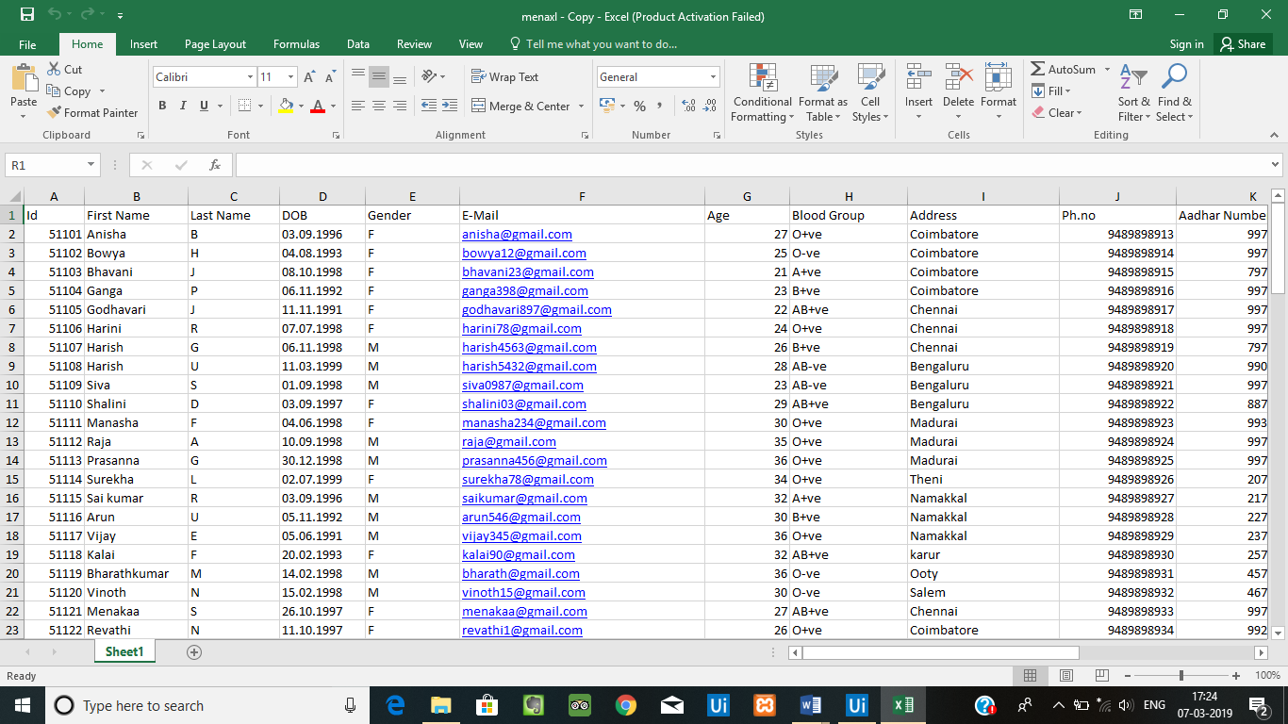

**WORKFLOW:**

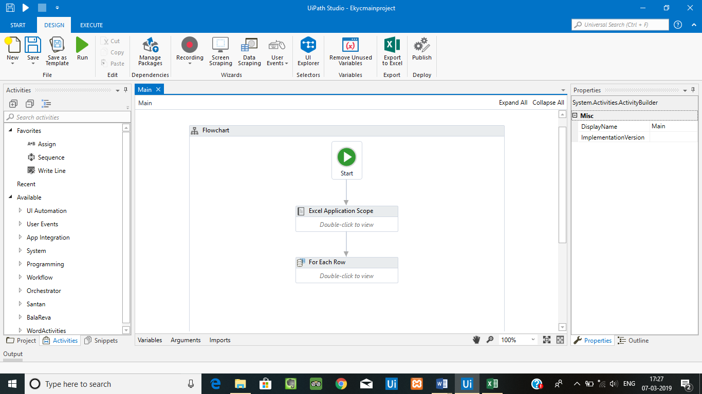

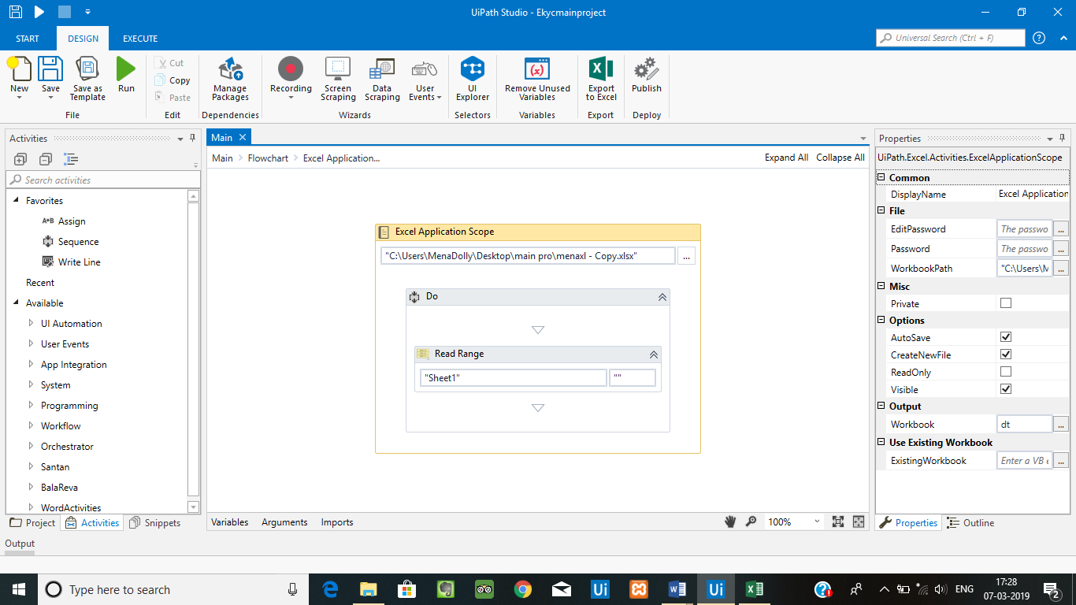

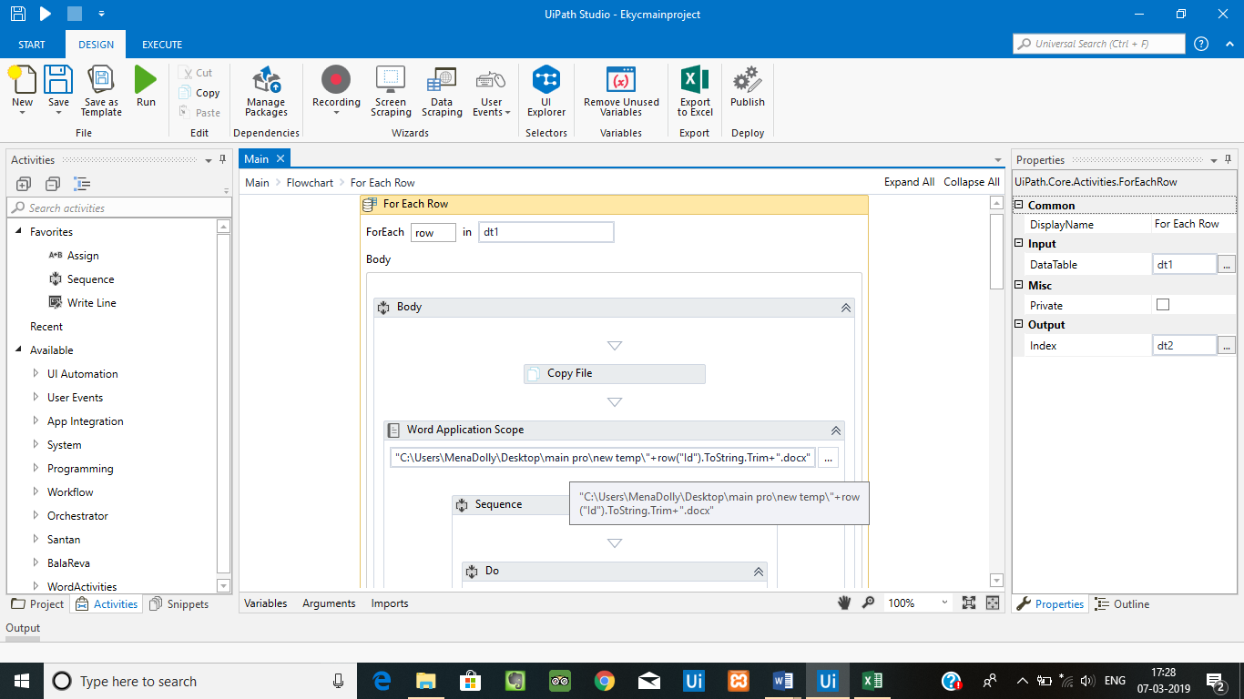

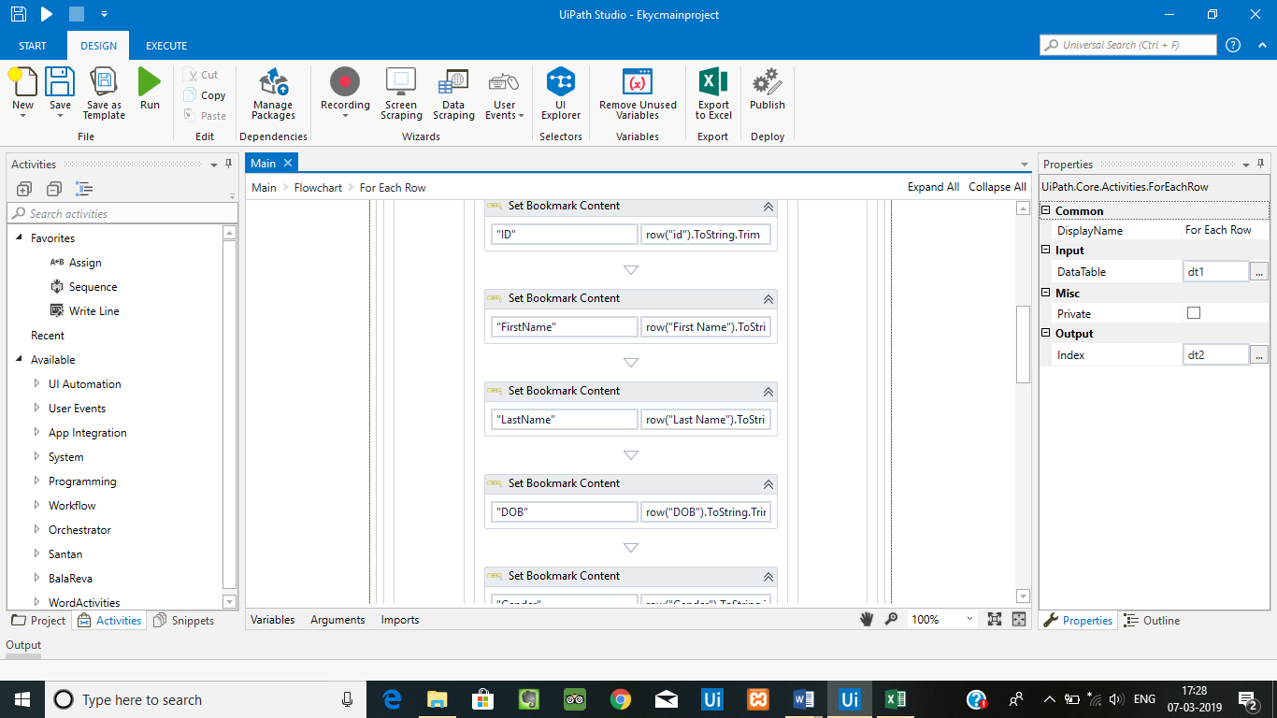

**OUTPUT:**

The details which are collected by the consultancy will be given as the input to the bot and the bot should fill the EKYC form. The form will be in the form of pdf.

